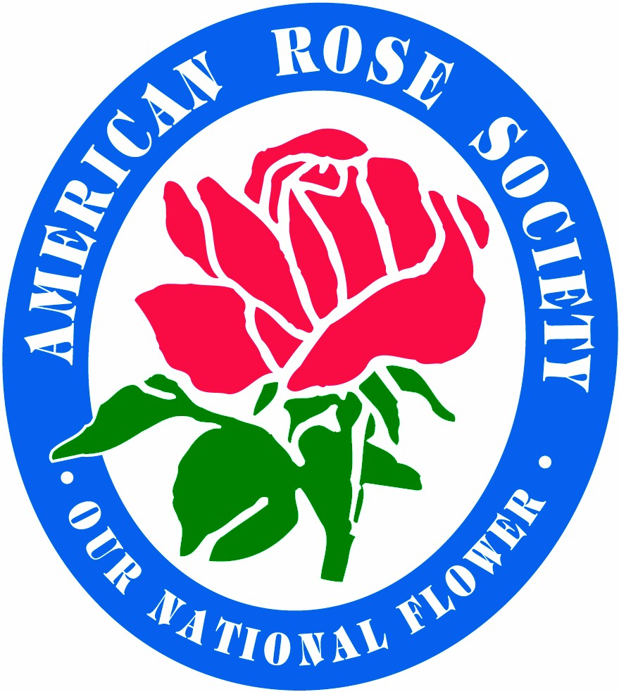
American Rose Society
~Since 1892~
P.O. Box 30,000 * Shreveport, LA 71130-0030
8877 Jefferson Paige Rd. * Shreveport, LA 71119-8817
Phone: 318-938-5402 * Fax: 318-938-5405 * E-mail: ars@ars-hq.org

CONSULTING ROSARIAN SCHOOL
REVIEW TEST DISCLAIMER

Please print:

Date:______________________ Current CR ___________________ New CR Candidate _________________________
(must be a member of ARS for past 3 years)

Name:______________________________________________________________________________________________

Address:____________________________________________________________________________________________

City, State, Zip +4:___________________________________________________________________________________

Telephone:______________________________ E-mail Address:______________________________________________

Local Rose Society:__________________________________________ ARS District:_____________________________

I understand that the American Rose Society is not responsible for any recommendations made by me, as a Consulting Rosarian, that are contrary to the Consulting Rosarian Manual or the Environmental Protection Agency’s regulations for my state. I also pledge my earnest efforts to uphold the highest standards of the American Rose Society in inspiring the love and appreciation of roses.

Signature: __________________________________________________________________________________________

I am willing to have my name and phone number released to the public by ARS.

Signature: __________________________________________________________________________________________

NEW CANDIDATES: The letter of verification that you have provided three letters of recommendation from your District Chairman of Consulting Rosarians is required.

QUESTIONS ARE BASED ON THE TEXT SECTION ONLY OF THE CR MANUAL

Revised 7/01

