SCD Consulting Rosarian School
Hosted by Houston Rose Society
October 4, 2008

South Main Baptist Church of Pasadena
4300 E Sam Houston Parkway S (Beltway 8)
Pasadena, Texas 77508

Saturday, October 4

8:00 – 8:30 Registration – SMBC
8:30 – 8:35 Welcome Donald Burger, Houston Rose Society President
8:35 – 8:50 Consulting Rosarian Mission – Ed Bradley, SCD CR Chair
8:50 – 9:45 Soils and Water – Baxter Williams, SCD District Director
9:45 – 10:00 BREAK
10:00 – 10:55 Fertilizers and Amendments – Tommy Hebert, SCD Prizes & Awards
10:55 – 11:45 Diseases and Cures – Mike Becker, SCD Secretary
11:45 – 12:45 LUNCH
12:45 - 1:35 Chemicals Safety – Donald Burger, HRS President
1:35 – 2:30 Insects and Cures – Mary Fulgham, HRS CR Chair
2:30 – 2:45 BREAK
2:45 – 3:40 New Varieties – Robin Hough, SCD Arrgmts Chair
3:40 – 3:55 BREAK
3:55 – 4:55 CR Exam for Consulting Rosarian Candidates

Consulting Rosarians will receive renewed accreditation for the next four years.

REGISTRATION
Please type, or print:

Name(s): ______________________________________________________________________
Address: _______________________________________________________________________
City: ______________________________ State: _________ ZIP: ______________________
Phone: (_______) _________________ E-mail: ______________________________________
Local Society: _________________________ District: __________________________________

Number Price Total
Registration (postmarked BY September 10, 2008) _______ $40.00 _____
Registration (postmarked AFTER September 10th) _______ $50.00 _____

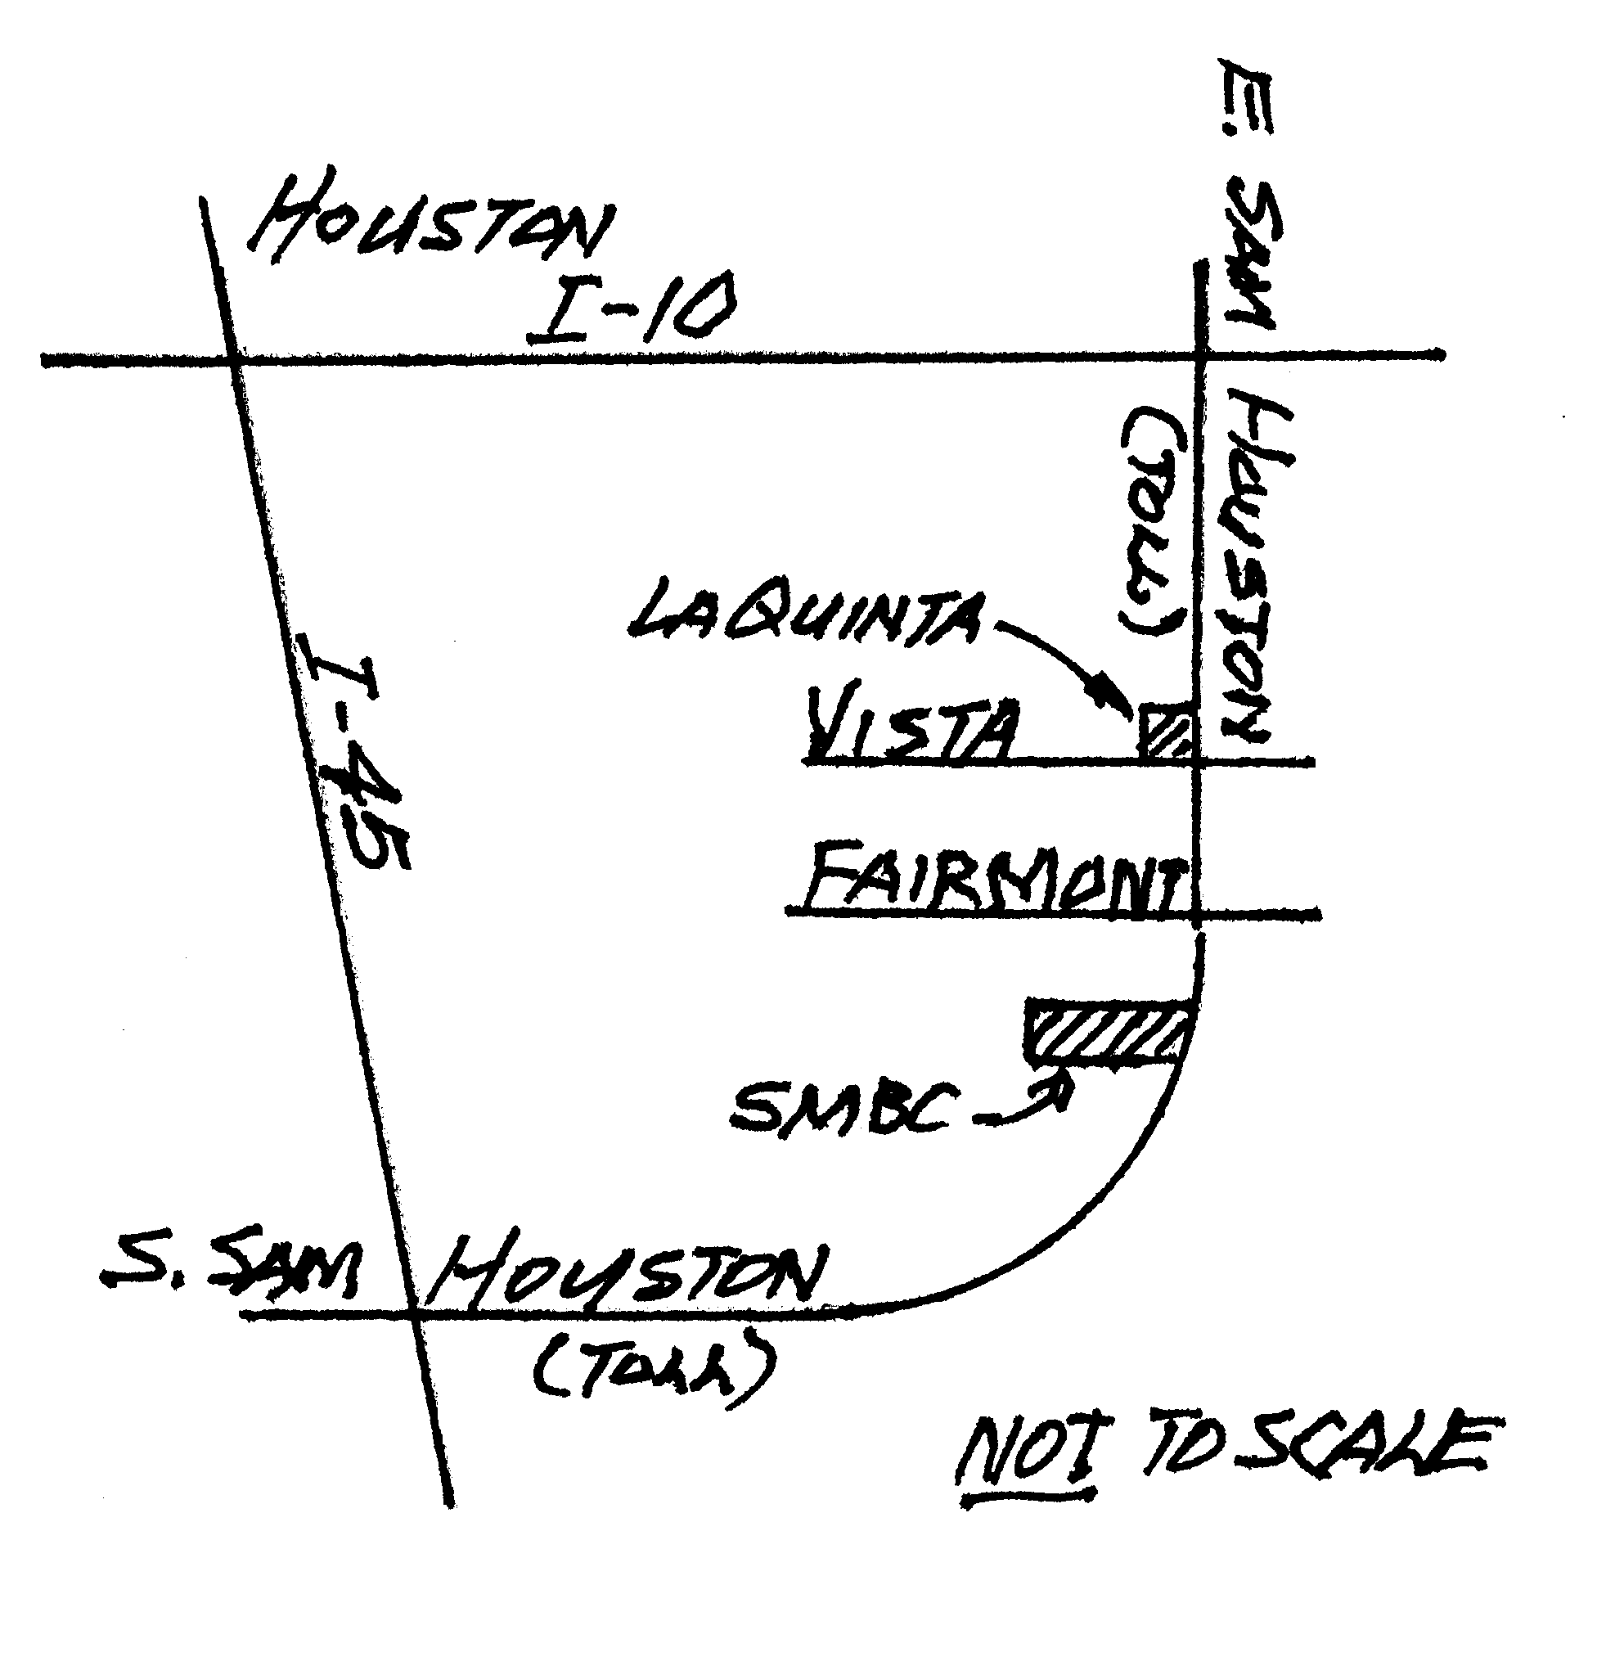
Please check if you are auditing the School ___________
Please check if you plan to take CR Examination ___________

Make checks payable to Houston Rose Society, and mail to: Baxter Williams, 2502 Leprechaun Lane, Houston, TX 77017.

Hotel accommodations at La Quinta Inn & Suites, 3490
E. Sam Houston Pkwy S at Vista Rd, Pasadena, TX
77505, 281-991-7771, Reference “Roses”. Rates -
King size bed @ &79 – Two Queen size beds (+ sofa
that makes into queen) @ $84 – Suite (+ sofa that makes into queen) @ $98. Complimentary Continental breakfast included. Note cut-off date: Sept 10th.

Note: The South Main Church location is two long blocks south on the same side of the freeway.

