MARK CHAMBLEE:

A Texas Treasure

Mark Chamblee literally was raised in the rose business. A third-generation rose grower, Mark's family has been prominently involved in the shaping of the Texas rose industry for more than 60 years. "If I didn't love this business, I wouldn't have stayed in it my whole life!" exclaims Mark.

Photo from Mark - full size.tifWith its roots dating as far back as the 1870s, roses have been a part of the Texas horticulture landscape. Built on hard work, by the 1920s roses were big business in Tyler, but it was not until the 1940s when cold storage facilities were built and plastic bags began to be used for packaging of plants that the industry got a jump start. By 2006, rose production represented one-third of the ornamental plants grown in north-east Texas.

Mark knows hard work. His earliest memory of roses is riding on the fender of the family's Farmall tractor while his dad, Roland Chamblee, tilled the rose fields. From the looks of the photo, Mark was probably two years old. Grandpa Roland shared that it was big day when Mark got tall enough to reach the pedals on the tractor and plow the rose fields by himself.

On one of our many rose road trips, Mark shared that he never intended to get involved in the family's rose business. He had enrolled in college and found that he really enjoyed the business classes. Answering the call for help from his dad, Mark found that he was able to put what he had learned in college to work and help grow the family's rose business. Eventually, Mark bought Chamblee's Rose Nursery from his dad in 1982 and expanded the retail side by adding a mail-order component.

What made Chamblee's Rose Nursery different? When I first met Mark and his family (way before either of us had white hair), commercial rose growers around the world were producing field-grown grafted roses. Mark knew the devastating effects that weather could have on a business. Thus he set about to grow roses as own-root plants. Greenhouses were constructed to better manage the effects of freezing temperatures and drought conditions on the roses. Another plus for the greenhouse operations was that treatments for pests and disease were better directed. At its height, the nursery boasted more than 70 greenhouses calling home to fabulous roses created by breeders from all over the world.

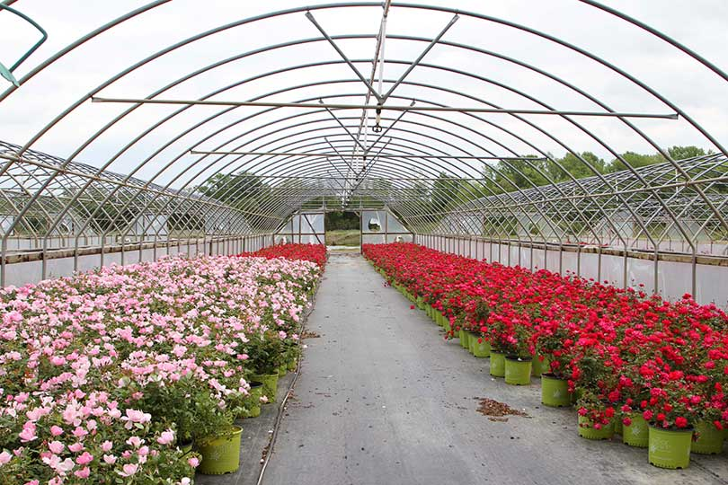

One of the greenhouses with Knock Out and Blushing Knock Out Roses, photo courtesy of the Texas Farm Bureau

"At one point, more than half of all the roses produced in the world were produced in the Tyler area, with more than 20 million rose bushes produced annually," Mark explains. By the late 1950s, the use of refrigerated box cars reduced shipping costs which enabled "Tyler roses" to be shipped across the county. By 1973, one estimation pegs worldwide shipment of Tyler roses at $9 million - a huge number in that day and age.

Back then Tyler boasted more than 65 rose growers. The big freeze of 1983 had a massive effect on the Texas rose industry. "That freeze took out three years' worth of crops," says Mark. Tyler rose growers lost their seedlings (plants that had just started), budding roses (one year plants) and the more mature bushes in the fields that were within the finish line of being harvested. Most farmers just could not recover from that type of loss. With freezes and droughts, an exodus on the growing side of the industry shifted from Tyler to California. The number of growers gradually dwindled to five, including Chamblee's Rose Nursery.

"California had large, flat acreage that can be plowed and irrigated. In Bakersfield (southern end of the San Joaquin Valley) a grower could have a million rose bushes in one field. You just can't do that in East Texas," explains Mark.

What California does not have are rose processing houses. It matters not whether rose bushes are grown in California or Arizona, they all get shipped to Tyler for processing, packaging and shipment to other parts of country. Grafted rose bushes grown in these states are harvested, bundled and shipped by refrigerated trucks to Tyler. The Tyler rose processing houses wash, trim and label the plants and then the roots are packed in a medium and packaged for shipment to retail outlets.

On the opposite end of the spectrum, an own root rose does not require special processing and can be shipped by Chamblee's Rose Nursery in the pot it was grown in. Mark is one of the reasons that own-rose roses have become so popular in the last 20 years. Retail nurseries love them because as own-root plants, rose bushes can be made available year-end, as opposed to the seasonal crop that grafted bushes represent. If the nursery you frequent showcases own-root roses throughout the year, you can thank Mark Chamblee for that!

As a licensed grower for world's oldest and biggest hybridizers of roses, one could find roses created by Will Radler (father of the Knock Out® series of roses), Meilland International (one of France's oldest rose breeding families), Star Roses and Plants, Kordes & Sohne Roses and David Austin Roses, Ltd. among the offerings at Chamblee's Rose Nursery.

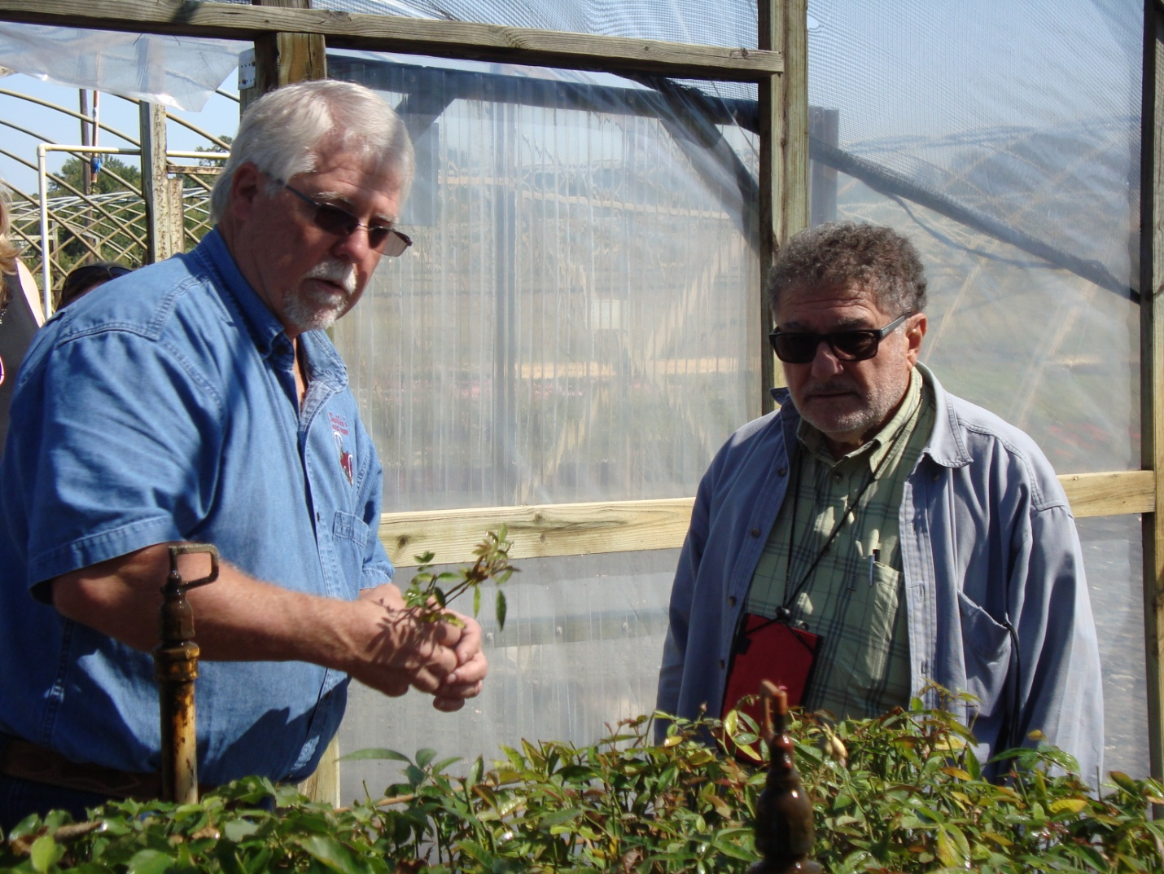

Mark demonstrates his propagation techniques to Alain Meilland from the House of Meilland (France).

A tireless advocate for the rose industry, Mark works with the Tyler Visitors Bureau and the Chamber of Commerce sharing knowledge with industry and the public alike. If one sits by Mark long enough, they are apt to hear wonderful stories about the world of roses.

One of his special projects has been as a consultant to the Tyler Rose Garden Center (location of the Tyler Rose Festivals and the Rose Museum). Established in 1933 by the Tyler Garden Club, the Tyler Rose Festival was created to celebrate the contributions of rose bush sales to the economy of Smith County. For the Rose Garden, Mark established a rotation cycle for plantings that also included the latest and best growing practices. With the average life span of a rose being seven years, a healthy rotation of bushes in the rose garden would limit the damage of a hard freeze on the overall health of the garden. Mark also advises the staff on rose varieties that require fewer chemical treatments for pests and disease - as well as those plants that are just drop-dead gorgeous!

But it is just not roses that Mark has been immersed in. Mark has held leadership roles in both the Texas Farm Bureau (State Director) and the Texas Nursery and Landscape Association (State Director/Vice President.)

"Mark is one of the finest gentleman I know!" exclaims Dr. Steve George, Horticulture Specialist, the Texas A&M AgriLife Extension Service. When the university's Earth-Kind® Rose and Landscape Management programs were in their infancy, Mark committed to carry every rose variety that was part of the Earth-Kind® research program in his nursery so that people everywhere could have experience with the same roses being researched by Texas A&M. He was also responsible for the huge planting of roses in the highway medians in Tyler. Both of these represented a huge commitment of time and resources. In addition, Mark has served in an advisory position with the American Rose Trials for Sustainability® since 2012.

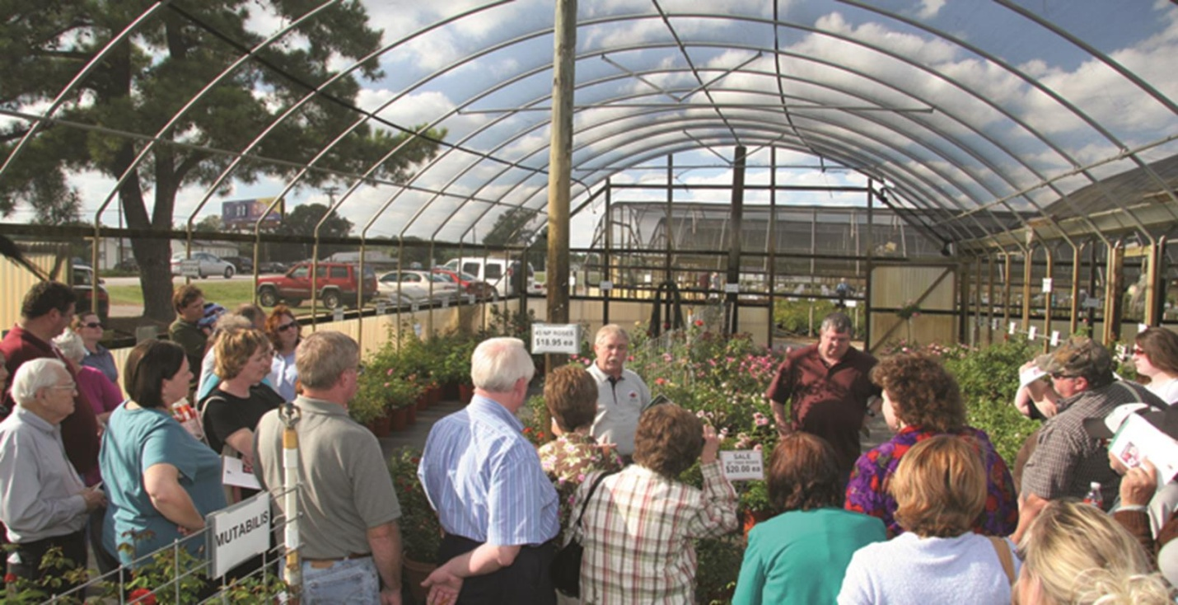

Mark regularly gave tours on weekends teaching visitors about growing roses in Texas

While retiring from the rose retail nursery in 2019, he remains active in the horticulture industry in Texas. In my opinion, Mark's desire to retire lasted all of about 24 hours, when he accepted a position with Vital Earth Resources, Inc. a producer of quality composts, landscape soils and fertilizers, including Carl Pool Products, Vitazyme and other agricultural biostimulant products.

Mark Chamblee is an iconic pillar of the rose industry in Texas and one of our State's horticultural treasures. I am proud to call him my number one "rose bud".